Ballroom Comp Manager Design Document

# Site Map

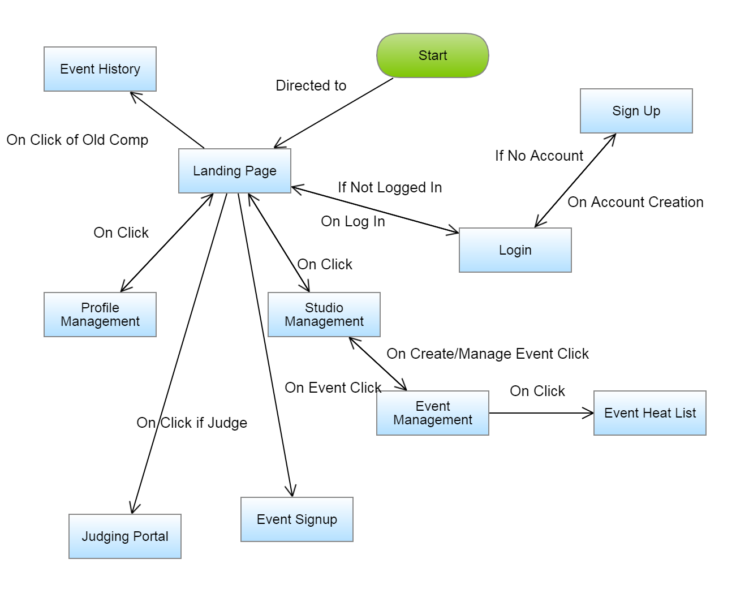

On Logout, Return to Login Module.   
Lines not shown.

# Modules

## Landing Page

### Features

List of Upcoming Events which can be selected for sign up or for judging (two separate   
links/buttons)

### Receives from Server

Events – array of JSON serialized events in the following format

{

id : Integer.

date : String. ISO 8601 format “YYYY-MM-DD”

registration_close_date: String. ISO 8601 format “YYYY-MM-DD”

name :String.

}

### Sends to Server

GET request to /event/(event_id: (0-9)+)/

Response:

redirect to Event Sign Up Module if future event

redirect to Event History Module if past event

GET request to /event/(event_id: (0-9)+)/judge

Response:

Redirect to /event/(event_id: (0-9)+)/ if not an authorized judge

Redirect to /event/(event_id: (0-9)+)/judge if an authorized judge

GET request to /profile/

Response: redirect to Profile Module

GET request to /studio/

Response: redirect to Studio Module

## Login Module

### Template

registration/login.html

### Features

A basic login form that accepts a username and password and validates the user.

### Receives from Server

Login Form – a Django-to-HTML5 form that must be used in order to authenticate the user

CSRF token

### Sends to Server

POST request to /login/

Data: Submitted Form

Response:

Refresh page with errors if bad auth.

Redirect to landing page (“/”) if good auth.

GET request to /signup/

Response: redirect to Signup Module

## Signup Module

### Template

session/signup.html

### Features

Form for creating a new account.

### Receives from Server

Django-to-HTML5 form for account creation

CSRF token

### Sends to Server

POST request to /signup/

Data: submitted form

Response:

Redirect to /login/ on successful creation

Refresh with errors on erroneous submission

## Profile Module Features

A table with a filter set for searching up personal results from past competitions

A change password area

A Studio association area

### Receives from Server

Profile information in JSON format

Format: {

Name: string

Studio: string or null

}

Change password Django-to-HTML5 form

CSRF token

Event results matching URL querystring filters

Array of events in JSON format client has participated in for populating a dropdown in the filter

Format: [

{

Name: String.

}

]

### Sends to Server

POST request to /profile/

Data: submitted form

Response:

Refresh Page with errors if change password was bad

Refresh Page without errors if change password was successful

POST request to /profile/associate

Data: association pin

Response:

Refresh Page with errors if pin does not match a school

Refresh Page with success message if association successful

GET request to /profile/ with querystrings

Parameters:

date: expected format = “YYYY-MM-DD”, competition date

name: competition name

Response:  
 Array of JSON serialized events with nested arrays of JSON serialized places in   
 the format:

[{

date: string, format: “YYYY-MM-DD”

event_name: string  
 placements: {  
 place: integer  
 event name: string  
 }

}]

## Event Signup Module

### Features

Form for Competition that imitates the functionality of the existing O2CM competition signup form.

### Receives from Server

Django-to-HTML5 form for event signup with prepopulated information for available dancers   
and events

CSRF token

### Sends to Server

POST request to /event/(event_id: (0-9)+)/

Data: submitted form

Response:

Redirect to “/” on successful submission

Refresh with Errors on erroneous submission

## Judging Module

### Features

Replicates the current judging system for marking contestants divided by heats.

Asynchronously checks for next event+round then loads next event+round after judge has   
 submitted the prior event’s round form

### Receives from Server

Django-to-HTML5 form for marking contestants, prepopulated with the dancers for that heat

CSRF token

### Sends to Server

POST request to /event/(event_id: (0-9)+)/judge

Data: submitted form

Response:

Refreshes with next event’s round on success.

Refreshes without losing data on same event on failure

## Event History Module

### Features

Replicates the current results system of O2CM

### Receives from Server

Array of JSON serialized events in the following format:

Format: [{

date: ISO 8601 Format, YYYY-MM-DD, string

name: String

}]

### Sends to Server

GET request to /event/(event_id: (0-9)+)/ with querystring arguments

division  
 age  
 skill  
 style  
 competitor

Response:

Array of event and round information in JSON format:

[{

event_name : string

rounds: [{

round_number: Integer,

results: [{

couple: {

lead: String

follow: String

}

Marked: Boolean

Total_marks: Integer

Place: Integer

}]

}]

}]

## Studio Management Module

### Features

List of events this studio has or will host.

Association Pin generator

List of dancers in studio and list of requested association

### Receives from Server

Information of studio in JSON format:

{

name: String

pin: Integer

events: [

{

Name: string

Date: String, ISO 8601, YYYY-MM-DD

Last_date_of_registration: String, ISO 8601, YYYY-MM-DD

}

]

}

### Sends to Server

POST request to /studio/pin

Data: new pin

Response:

refresh with updated pin on success

refresh with error on erroneous submission

GET request to /studio/competition

Response:

Redirect to competition management loading in the data of the event clicked

GET request to /studio/competition/new

Response:

Redirect to new competition creation form

## Competition Management Module

### Features

Event creation form if navigated to /studio/competition/new

If navigated to /studio/competition/(competition_id [0-9]+)/ List of clickable events which bring   
 up their list of rounds, with a list of dancers in the rounds. The event admin can change the   
 number of dancers in a heat, can DQ dancers, can select which heat is active, and can select   
 which event is active.

### Receives from Server

If its event creation:

A Django-to-HTML5 form for creating a new competition

If event already exists:

An array of JSON serialized events

[{

Name: string

Heats: [

Heat_number: Integer

Dancers: [{

Number: Integer

Lead: String

Follow: String

}]

]

}]

### Sends to Server

POST to studio/competition/(competition_id [0-9]+)/event/(event_id [0-9]+)

Data: CSRF Token

Response:

Activates event selected in URL

Front end should be updated by SPA framework.

POST to studio/competition/(competition_id [0-9]+)/event/(event_id [0-9]+)/round/(round_id   
 [0-9]+)

Data: CSRF Token

Response:

Activates round selected in URL

Front end should be updated by SPA framework.

POST to studio/competition/(competition_id [0-9]+)/event/(event_id [0-9]+)/round/(round_id   
 [0-9]+)/update_max

Data:

CSRF Token

Max: Integer

Response:

Changes max for that round.

Front end should be updated by SPA framework.

POST to studio/competition/(competition_id [0-9]+)/event/(event_id [0-9]+)/round/(round_id   
 [0-9]+)/disqualify

Data:

CSRF Token

Couple_id: Integer

Response:

DQ’s couple.

Front end should be updated by SPA framework.

POST to studio/competition/(competition_id [0-9]+)/event/(event_id [0-9]+)/enlist

Data:

CSRF Token

Couple_id: Integer

Response:

Adds Couple to event

Front end should be updated by SPA framework.

GET to studio/competition/(competition_id [0-9]+)/heat_list

Data: none

Response:

Returns HTML page of heat list that auto updates.

## Heat List

### Features

Recreates O2CM heat list which auto-updates.

### Receives from Server

Array of JSON serialized events and heats in order of chronology;

Format:

[{

Name: String. Event and Heat combined.

Heat_number: Integer

Couples: [{

Number: Integer,

Lead: String

Follow: String

}]

isFinal: boolean

}]

### Sends to Server

Nothing

## Algorithm for Calling Back Dancers

### Non-Final Rounds:

Judges are given X number of marks. At the end of the round, the X number of dancers with the   
most marks are called back to the next round. Ties result in the tied couples being brought to the next round automatically.

### Final Rounds:

Judges assign 1-X (where X is the number of finalists) to each dancer. A majority of judges must   
assign the same number to a dancer for the dancer to receive that place. If there is no majority, then all the 1-2s are counted up, and those with the highest are then compared. If a winner exists than that winner receives 1st place. Else all the 1-2s are added per dancer and the lower total wins first place. If a tie persists than the process is repeated, but including 1-3. Only once all X places are included is a tie declared. Then the process starts again with 2-3 to find the second place, and so on down.

## Database Schema

